**VPN Set Up Guide**

1. **NB:**

If you have **SecoClient** or old **BCC svn** client then first uninstall it from PC. (If not then skip it)

1. **Install UniVPN**
   1. **Downloading UniVPN Software**.

Download the target software from source link provided into mail and extract the zip file. After extraction you will find the file like below screenshot:

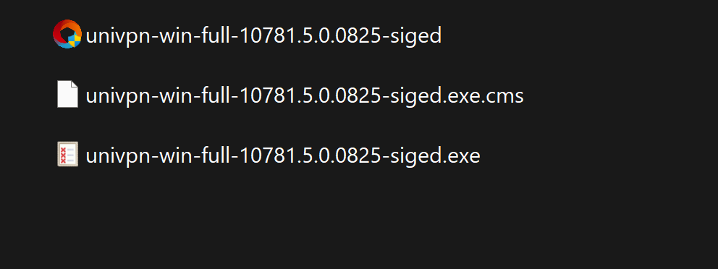

* 1. **Install UniVPN software**

Select the application **univpn-win-full-10781.5.0.0825-signed** file and install the application file with windows administrative privilege mode, that means run it ***Run as administrator***

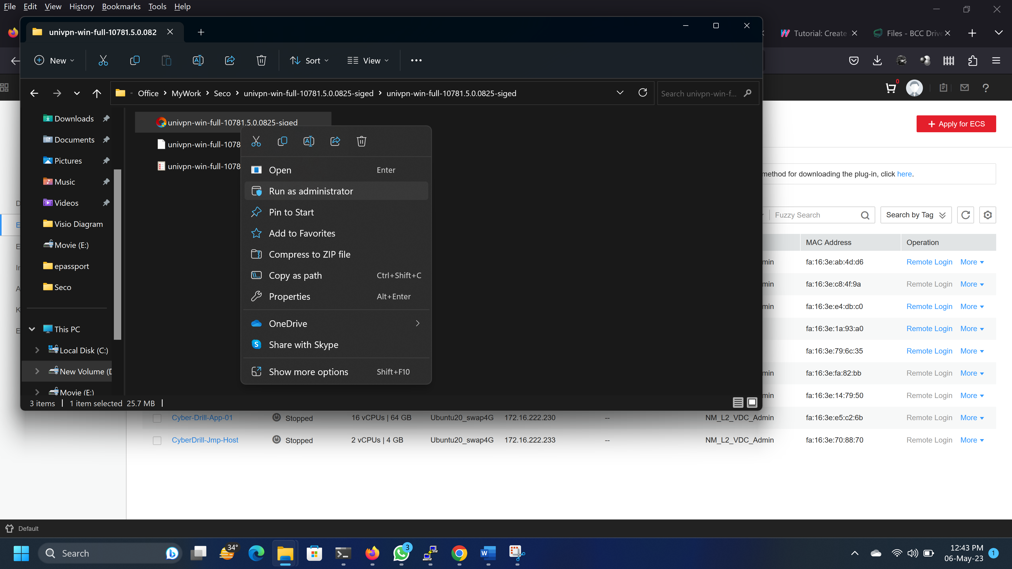

1. **Setting the VPN Parameters**
   1. **Open the UniVPN**.

Select <<**New Connection>>** .

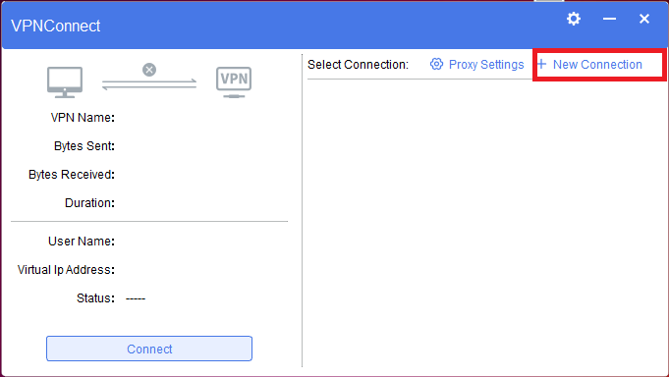

* 1. **Set SSL VPN connection parameter values.**

In the **New Connection** dialog box, select **SSL VPN** from the left navigation tree and set connection parameter values.

Connection Name: Any Identical Name

**Gateway address** is ***customer-vpn.bcc.gov.bd***

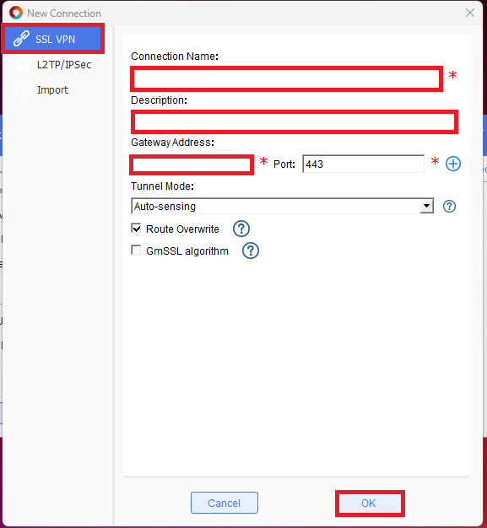

**Below is a demo setup** for Customer.

Gateway address is *customer-vpn.bcc.gov.bd* for SSL Vpn

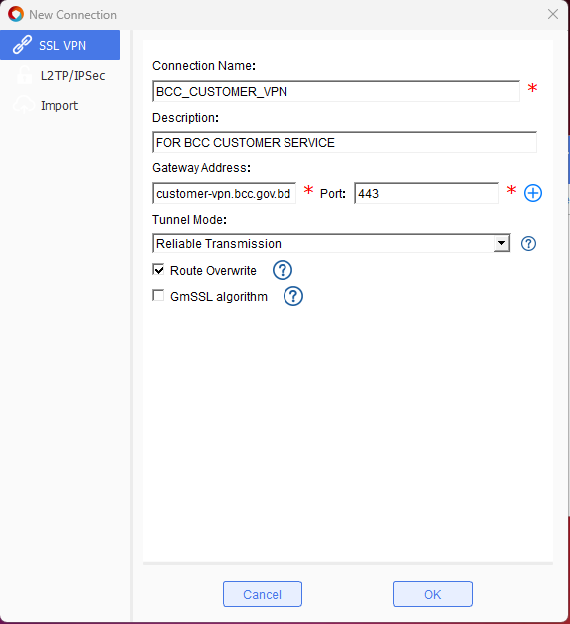

* 1. Click **Save**. The home page is displayed.
  2. Close it.

1. **Logging to the SSL VPN virtual gateway**
   1. Run the UniVPN client as ***Run as administrator*** (***each time when you want to loggin UniVPN)***

.

* 1. Select the created SSL VPN connection from the right side and click **Connect**.

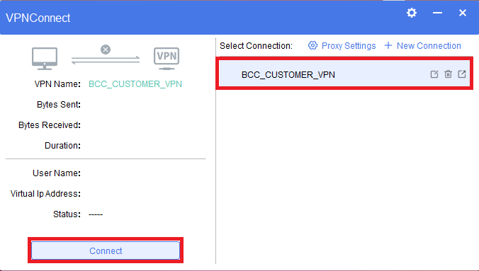

* 1. On the login page, username will be visible once certificate install properly enter password.

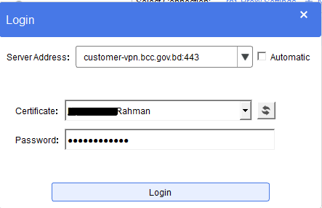

* 1. When Security warning message prompts click on change setting:

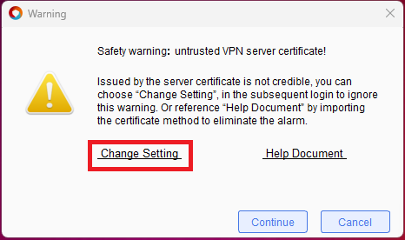

* 1. Uncheck below option and click OK.

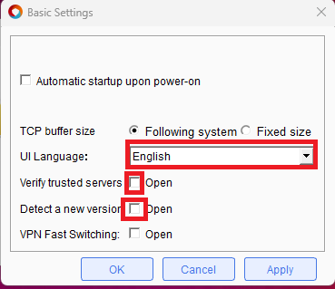

* 1. Click on **Continue.**

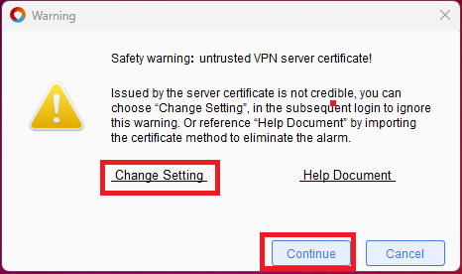

* 1. When the VPN access succeeds, a prompt is displayed at the lower right corner of the screen.

 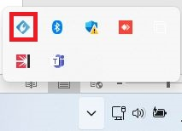

1. **UniVPN Password Reset Procedure**
   1. From the right corner of the PC taskbar right click the UniVPN icon you can find the change password option.

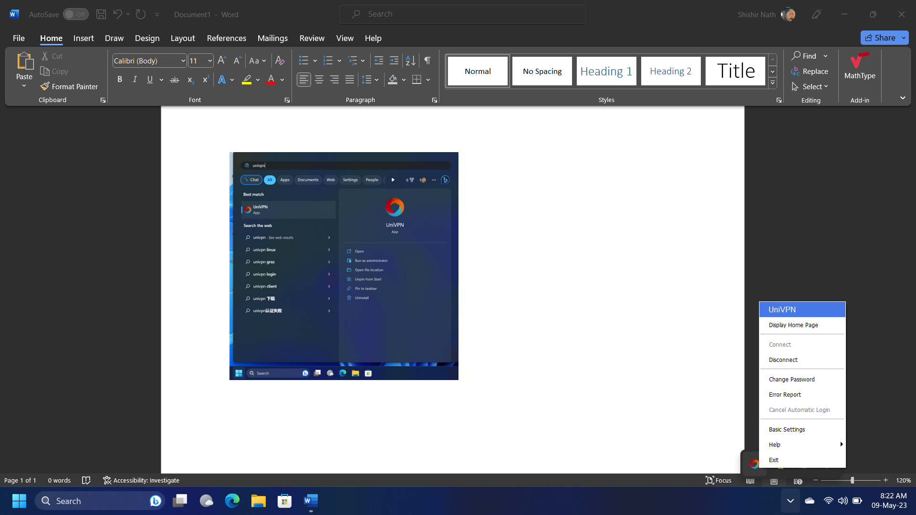

* 1. Or you can open the Display Home Page of UniVPN. From the page by clicking settings ☼ button you can also get option to change password

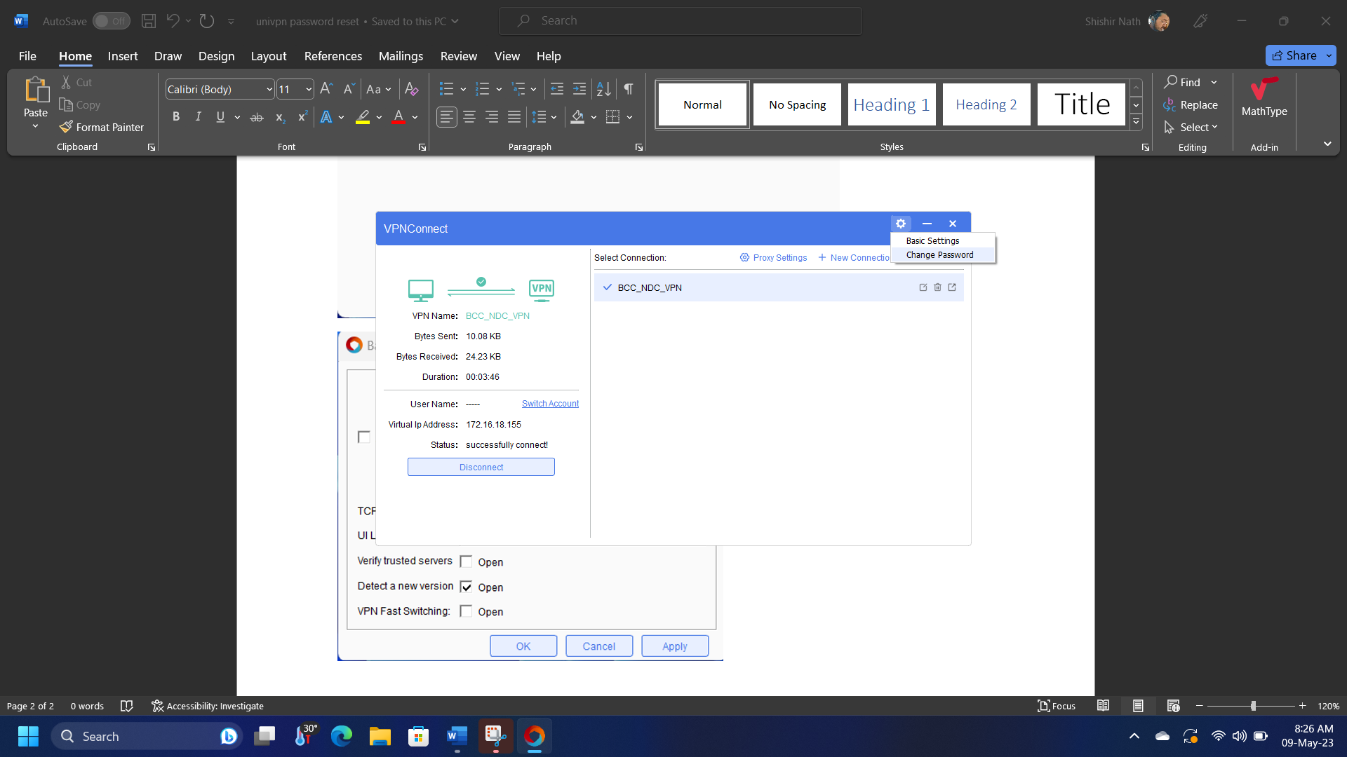

* 1. Now Confirm Password. After fill-up the below fields need to confirm by clicking OK button.

